Lab Assignment 2.4

Task Description #1:

Use google Gemini to generate python code that performs sorting of a list using both the Bubble Sort Algorithm and Python’s build in Sort function. Compare them.

Prompt:

Python program Sort function and bubble sort method with dynamic input and print them, give me comparison.

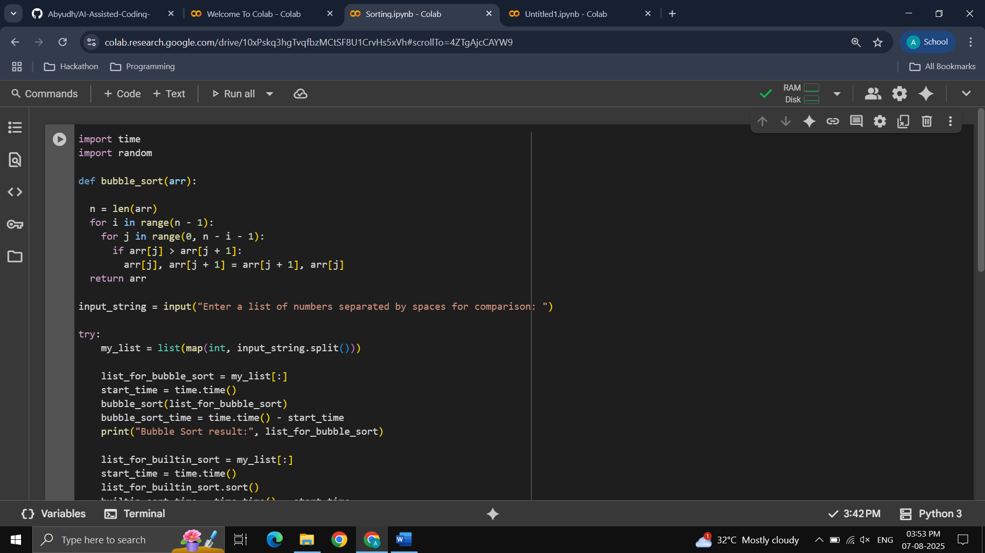

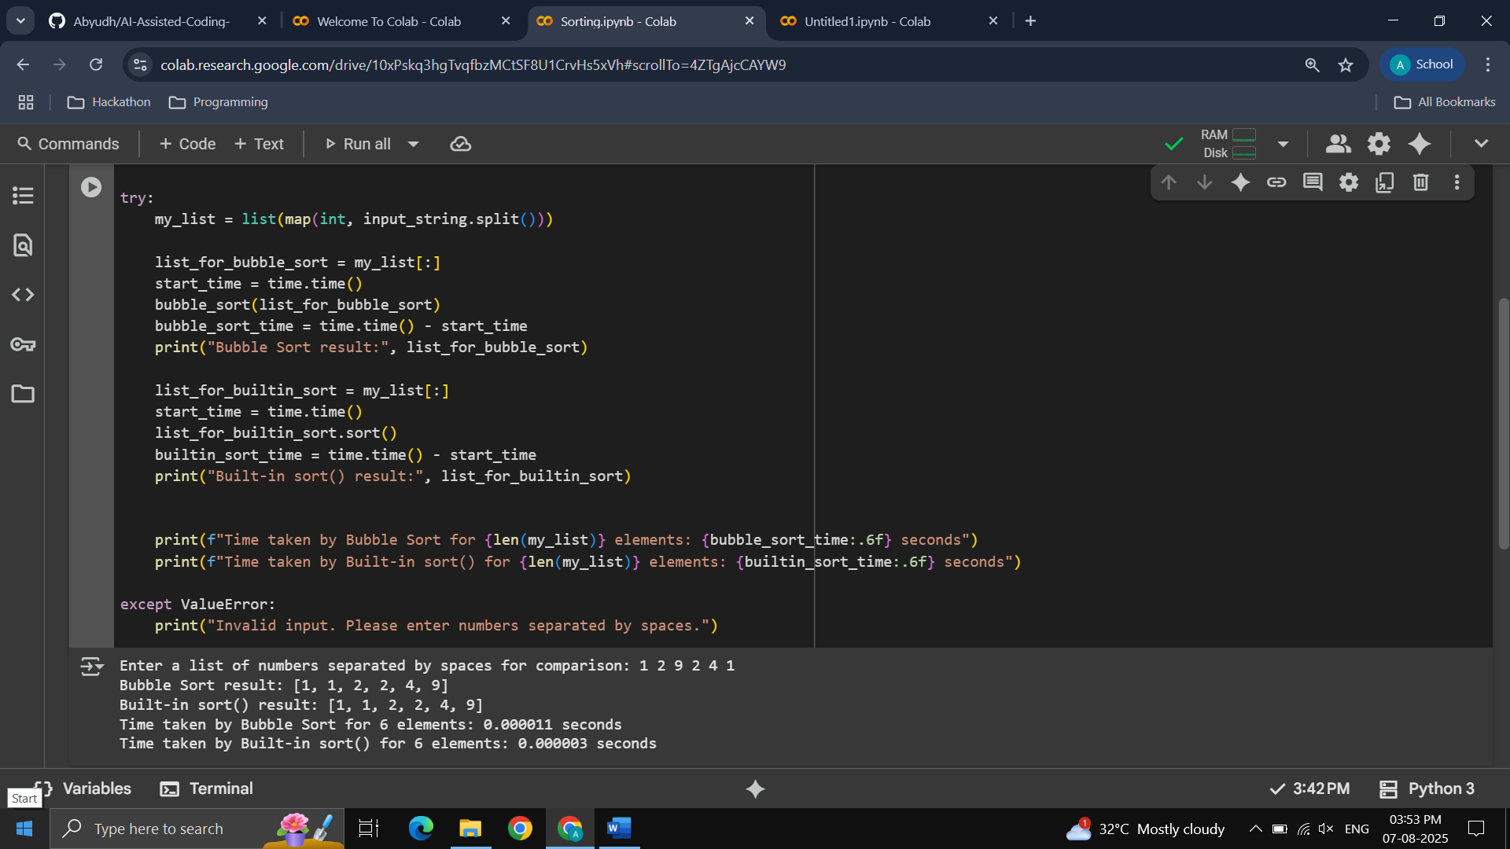

Task Description #2:

In Google colab, use Google Gemini to generate a python function that takes a string and returns. The Number of vowels, the number of consonants, the number of digits in the string.

Prompt:  
Python function to calculate no. of vowels, consonants and digits in with them with dynamic inputs

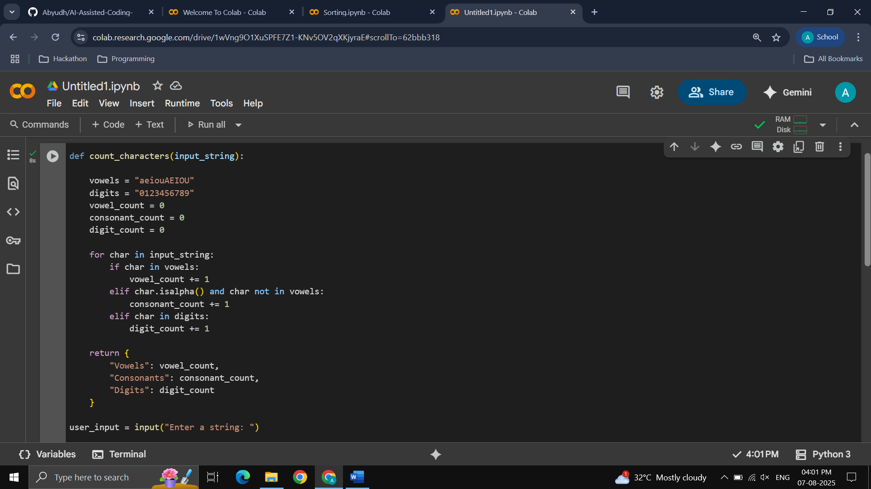

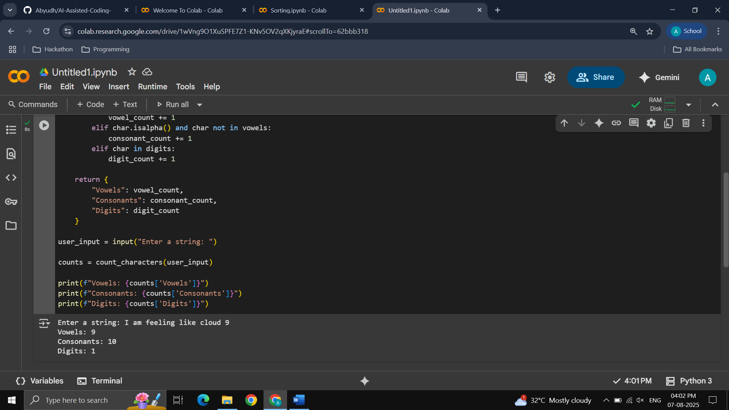

Task Description #3:

Use Gemini to generate a Python program that performs file handling:

* Create a text file
* Write Sample text
* Read and display the content

**Prompt:**

Python function for file handling, create a .txt file, take sample text input from user and read it back.

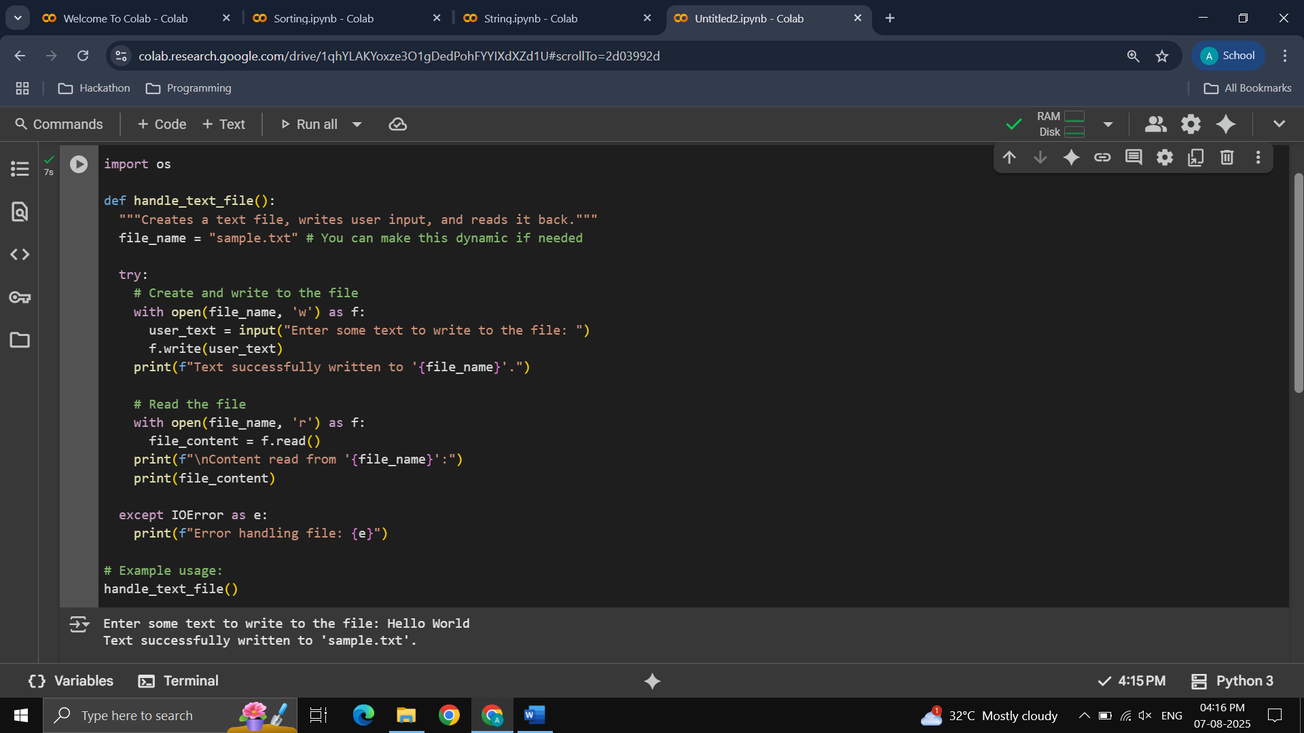

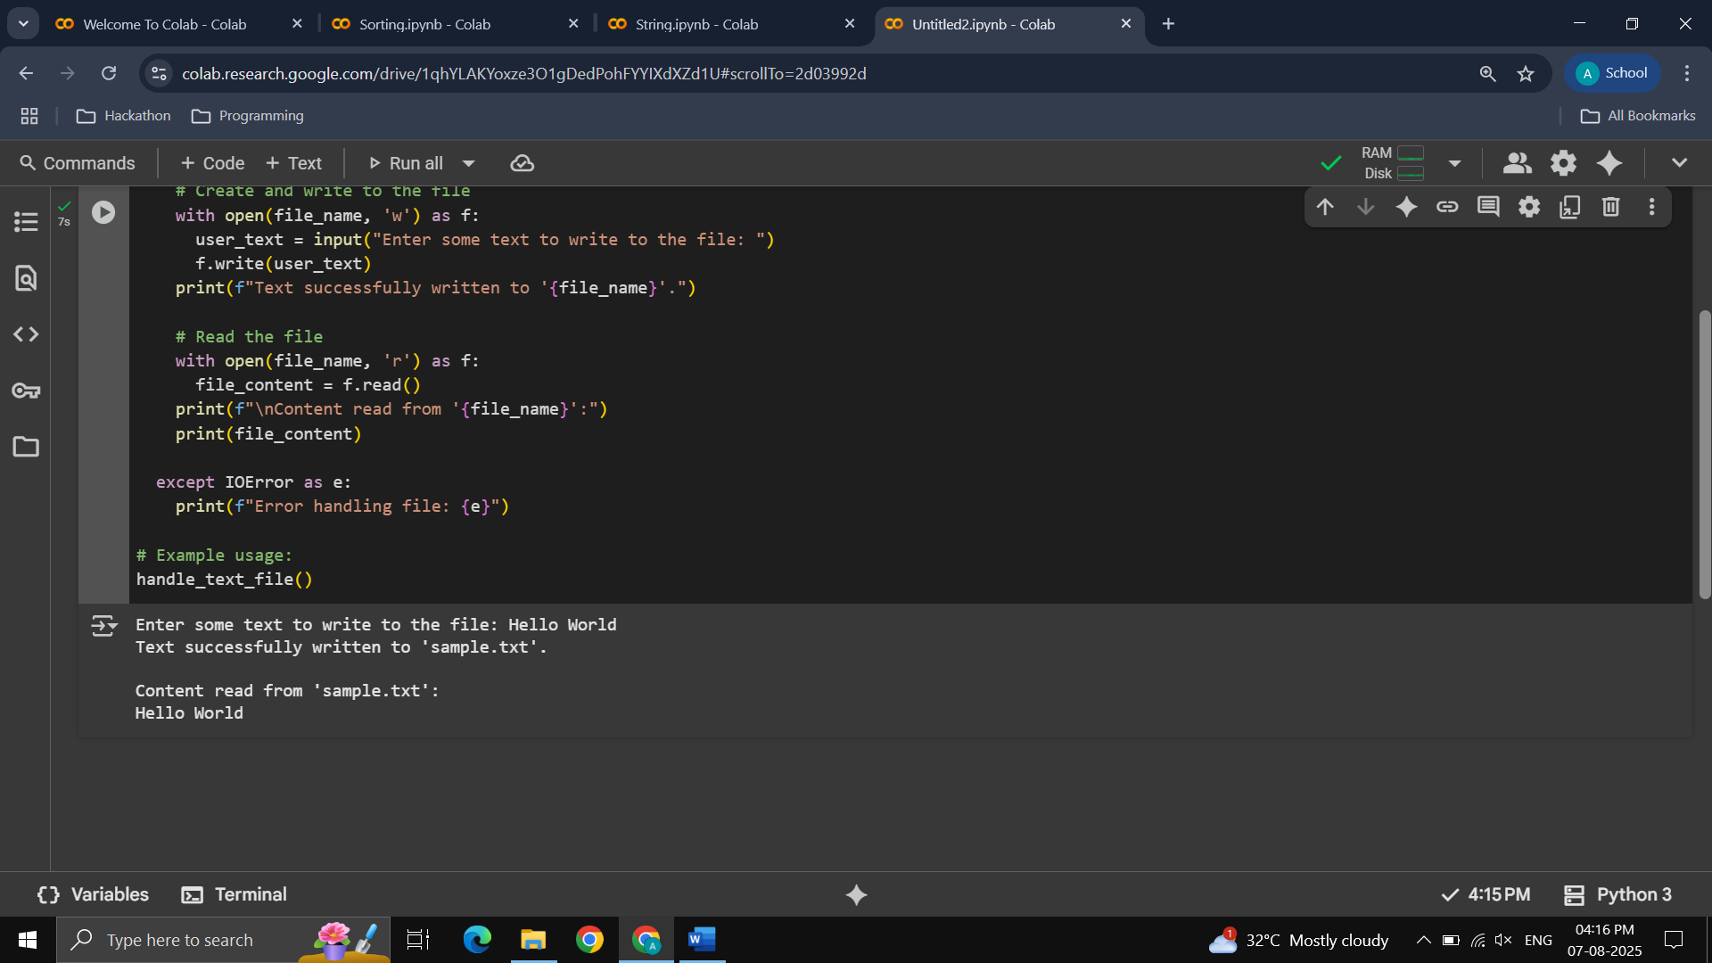

Task Description #4:

Ask Goggle Gemini to generate a Python Program that implements a simple calculator using functions (Add, Subtract, Multiply, Divide). Then ask Gemini to explain how to code works.

Prompt:

Python Program to make calculator with user input and operation selection : Add , Subtract, Multiply and Divide.

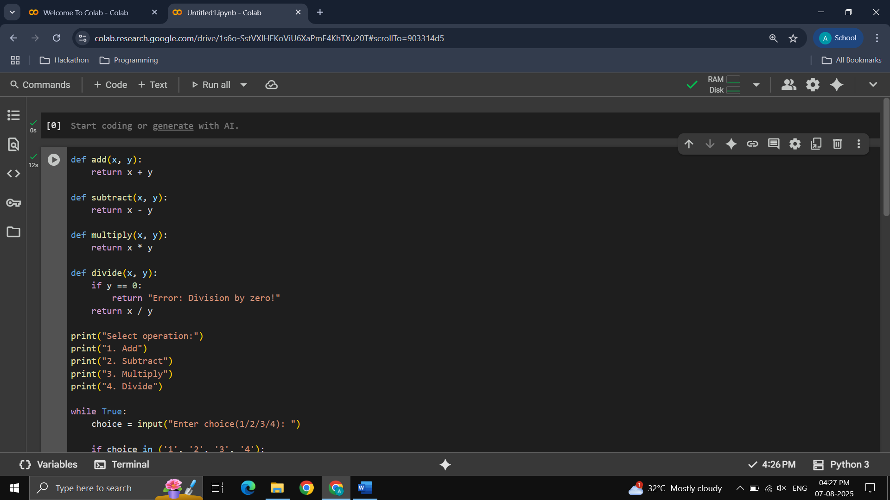

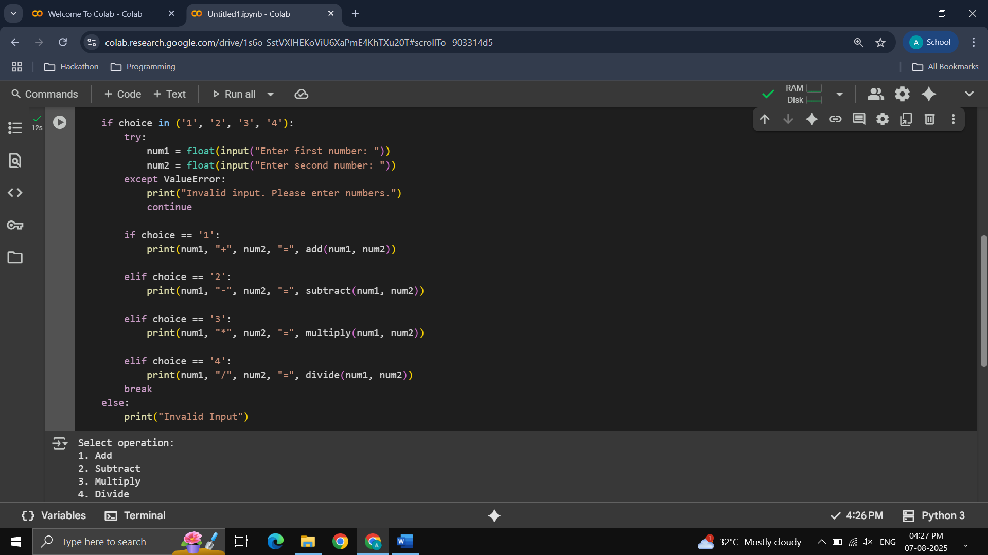

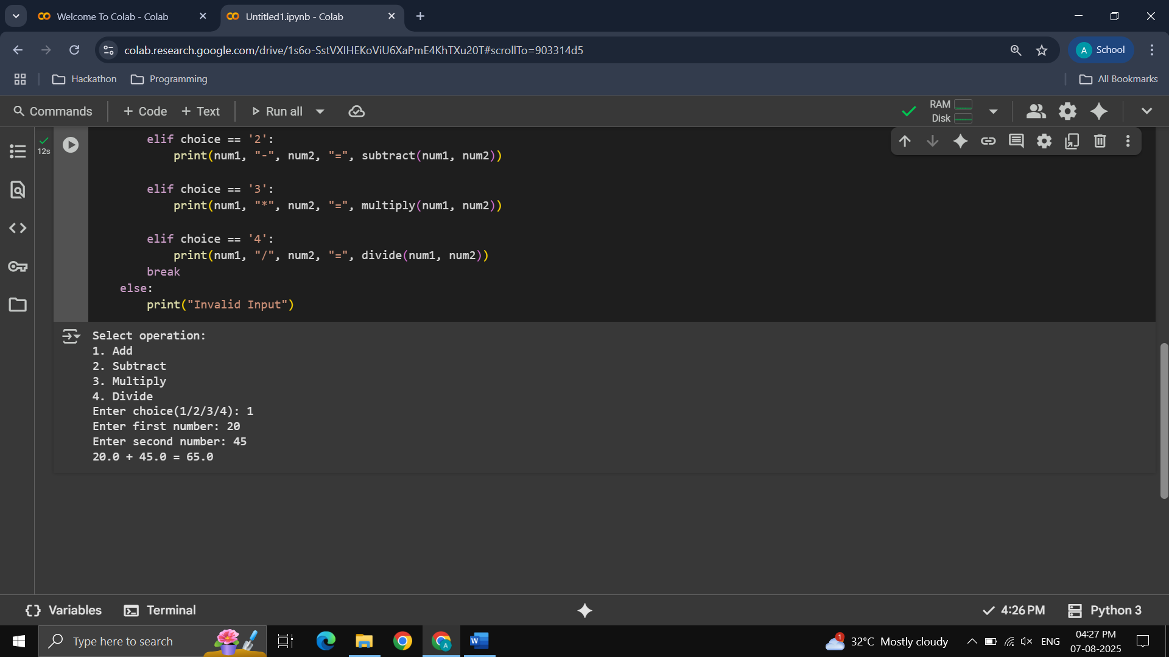

Explanation:

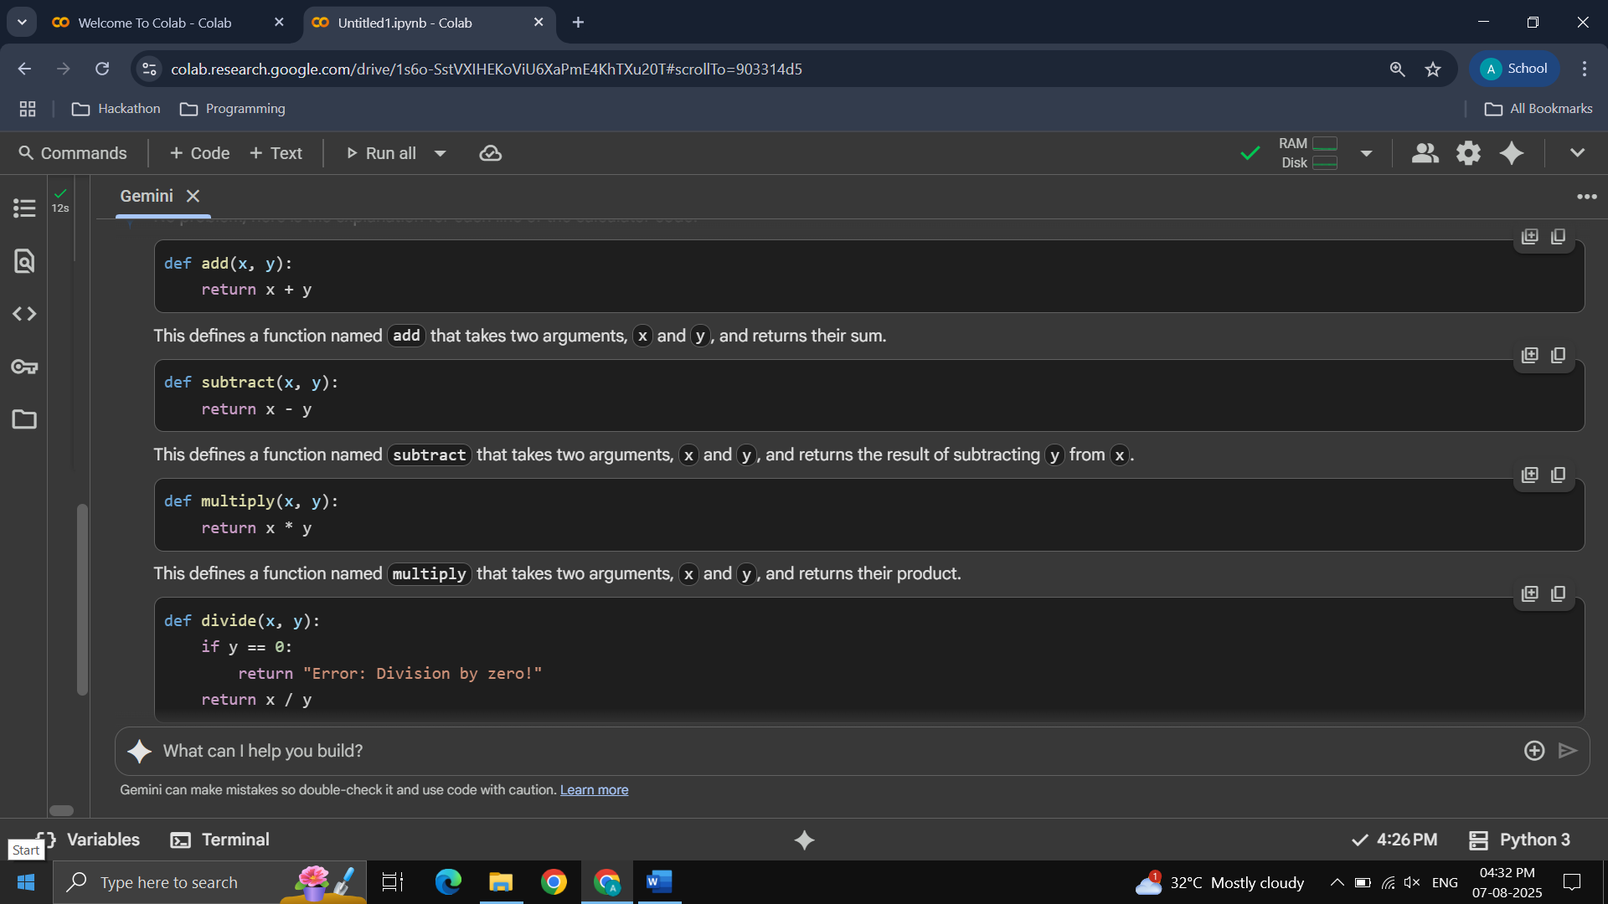

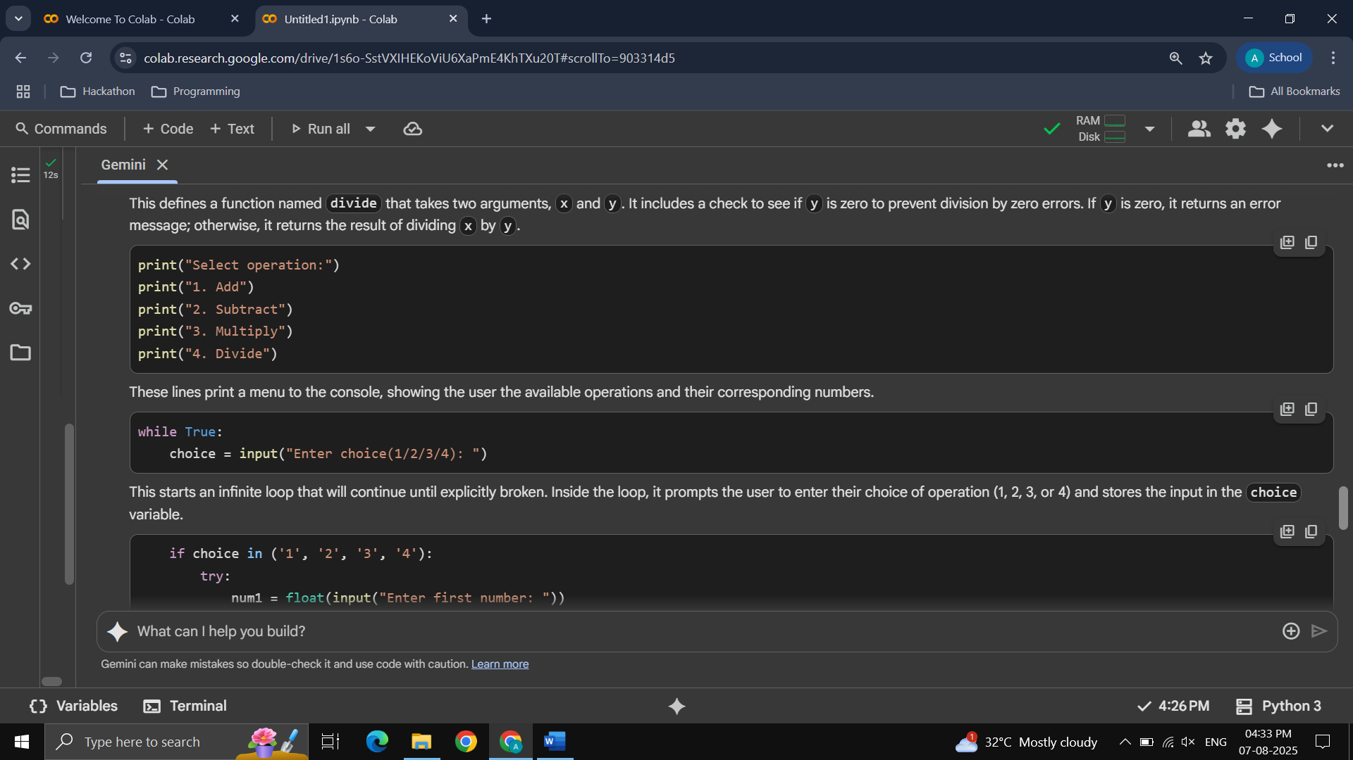

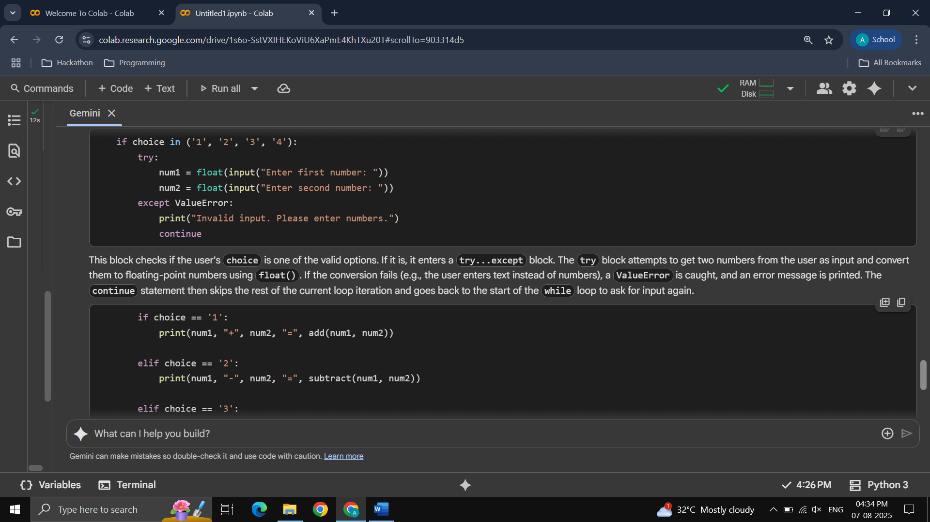

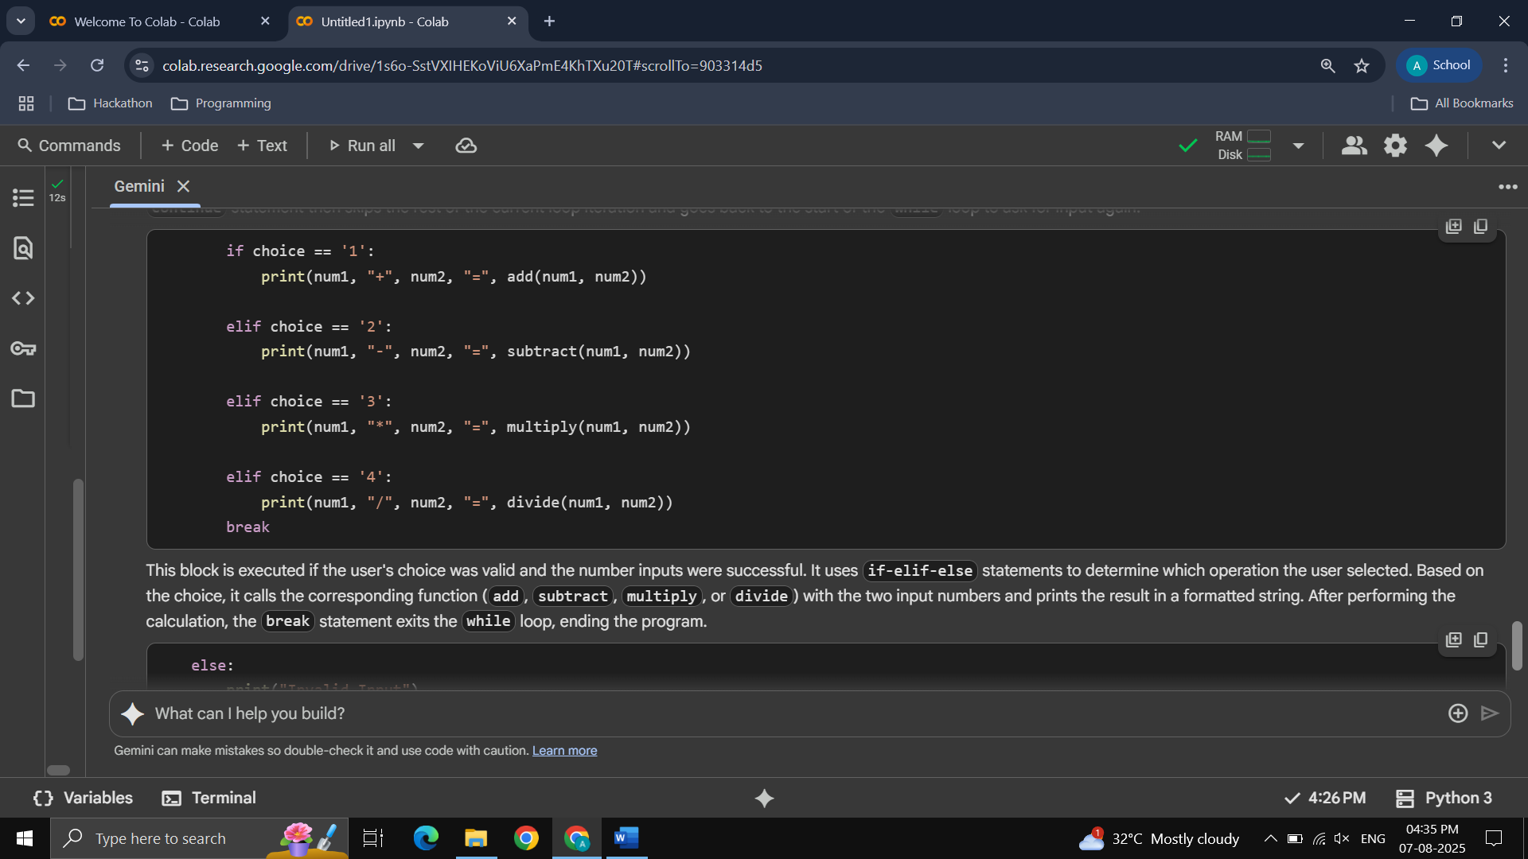

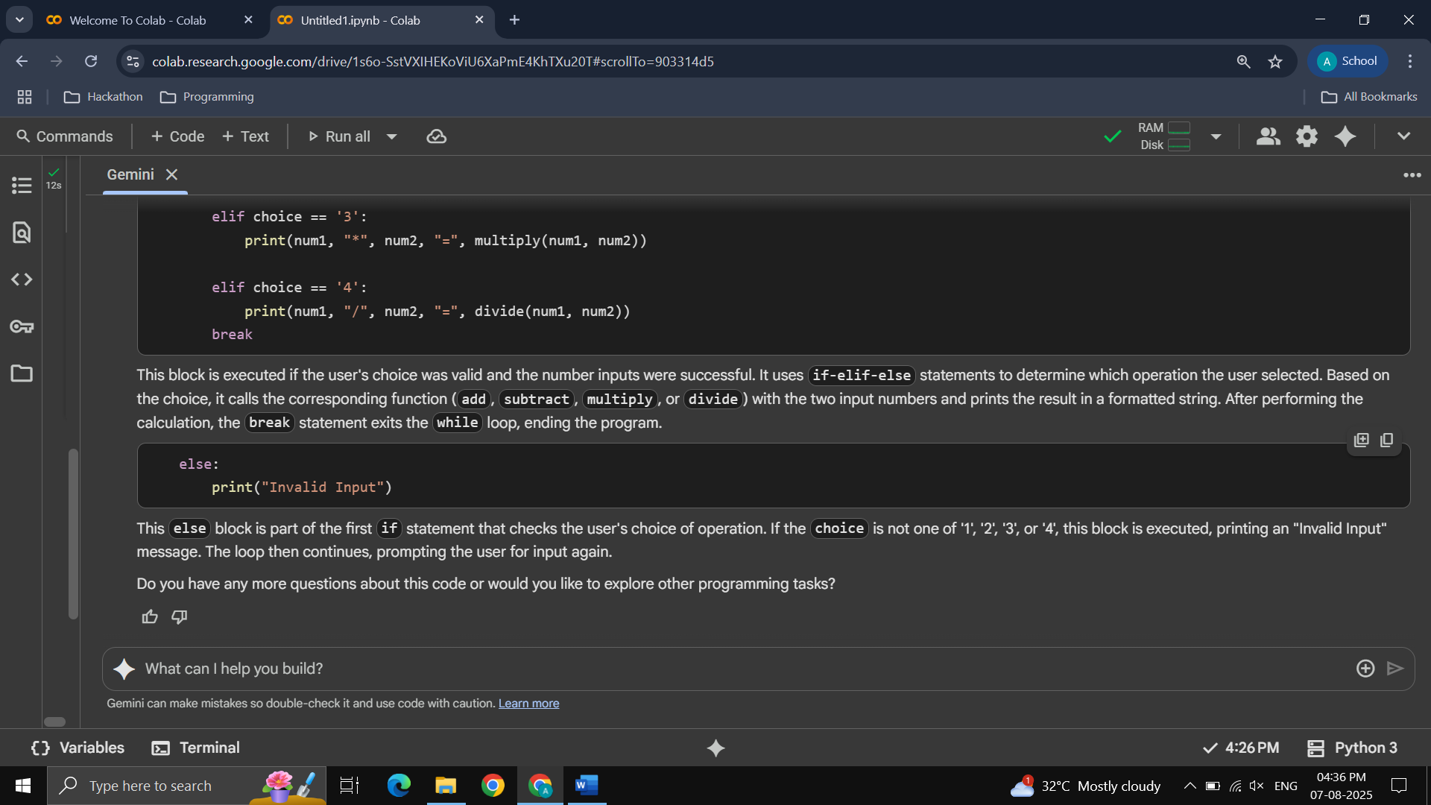

Task Description #2:

Use Gemini to create a Python program that checks if a given year is a leap year or not Try different prompts styles and see how Gemini modifies the code suggestions.

Prompt 1:

Write a python code to find the year is leap year or not, use dynamic input to take year

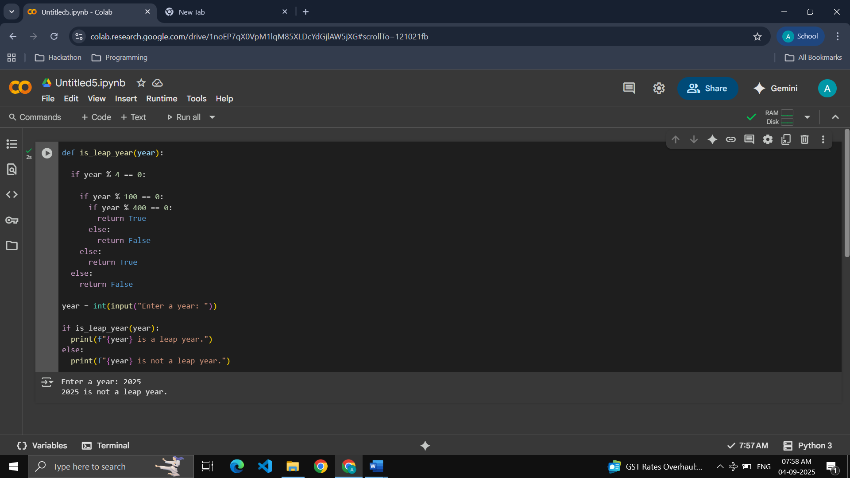

Prompt 2:

Check whether a given input of year is leap year or not.

